File Creation for VantagePoint Import from Selected Databases

- Proquest ABI Inform Complete
  - After running the search, scroll to the bottom of the results page and set the ‘results per page’ to 30.
  - Use the MARK ALL option to mark the 30 records on the page. ABI Inform allows only 50 records to be marked at one time.
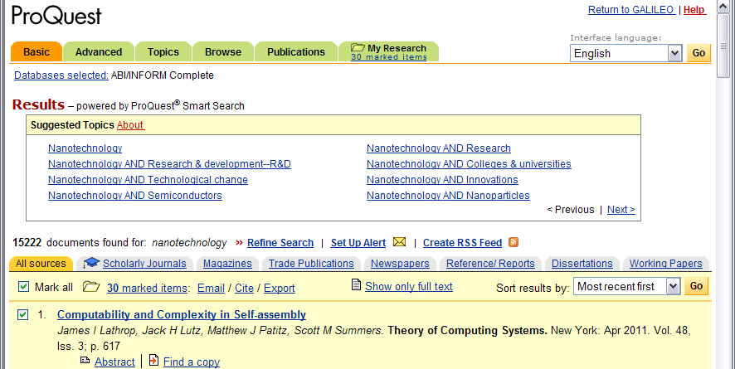
  - Click on the ’50 marked Records’ link.
  - Use the Export Citations option.
  - Select the “Download in a format compatible with ProCite, EndNote, Reference Manager, and RefWorks.” Option.
  - Use ‘save as’ from the browser’s file menu, and save as a .txt file.

  - Import into VP using the ABI Inform filter (ABI-Inform-Proquest).

